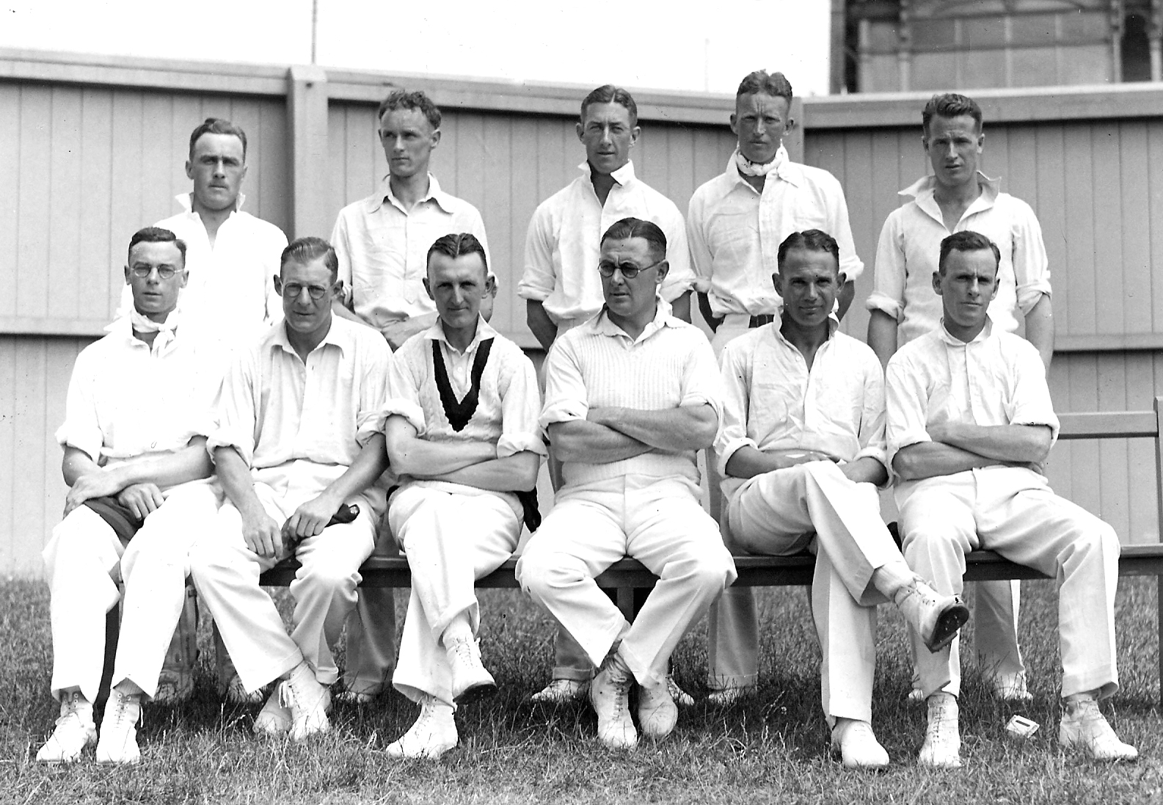

C**anterbury Cricket Representative Team 1935-36**

**Back row:** CKQ Jackman, M Graham, FP O’Brien, S Andrews, LA Butterfield

**Front row:** WA Hadlee, JL Kerr, FW Bellamy, IB Cromb (captain), AW Roberts, WE Merritt